
Course Submission Cover Sheet

Module: xxx

Assignment no: 001

Weighting: 100% of the module mark

Deadline: 3PM Wednesday the xxth of January 2025
Module Leader: xx Student ID: 00235590

Please note that there are specific regulations concerning the use of AI and Academic Misconduct. Below are extracts from these regulations. By signing, you acknowledge that you have read and understood these extracts.

(signature:) E224138@esoft.academy Date: 2026/01/21

This header sheet should be attached to the work you submit.

Academic Integrity means being honest in your academic work and your studies and making sure that you acknowledge the work of others and giving credit where you have used other people's ideas as part of presenting your arguments. Your assessment submissions must therefore always be entirely your own work, based on your own learning and appropriately referenced including how you have used Generative AI. The University regards the use of Generative AI applications by students to deceive to gain unfair advantage as academic misconduct. This usage includes:

- Plagiarism, where AI tools are used to generate output and ideas that are presented or submitted as if they were the student's own work, without proper citation or references.

- Where a complete assignment is created using Generative AI and represented as a student's own work, this will be regarded as contract cheating in the same way as commissioning an 'Essay Mill' or other third party to complete your work. Further information can be found on : Guidance on the use of Artificial Intelligence.

Academic misconduct: The University takes academic misconduct very seriously and seeks at all times to rigorously protect its academic standards. Plagiarism, collusion and other forms of cheating constitute academic misconduct, for which there is an explicit range of graduated penalties depending on the particular type of academic misconduct. The penalties that can be applied if academic misconduct is substantiated range from a reprimand to expulsion in very serious cases and for repeated instances of misconduct. You are also responsible for ensuring that all work submitted is your own and that it is appropriately referenced. The University does not tolerate cheating of any kind. You are strongly advised to familiarise yourself with the Academic Misconduct Policy and Procedure (Academic Misconduct), which list a range of categories of academic misconduct and associated penalties, covering instances of academic misconduct (plagiarism, collusion, exam cheating).

CS6003ES – Advanced Software Engineering COURSEWORK-1

Case Study: IslandLink Sales Distribution Network (ISDN)

IslandLink Sales Distribution Network (ISDN) is one of the island's largest wholesale and retail distribution companies, supplying over 5,000 active retail outlets, supermarkets, and small resellers with a wide range of Fast-Moving Consumer Goods. Packaged foods, beverages, home cleaning products, and personal care items are part of the products.
ISDN operates five regional distribution centres (RDCs) in the North, South, East, West, and Central provinces of the island. Each RDC services a cluster of districts such that deliveries reach customers within 24 - 48 hours. Head Office (HO) is located in the Central region and manages corporate operations, procurement, and strategic planning.

ISDN’s current operations rely heavily on manual processes across multiple stages, which significantly impacts efficiency and accuracy. Orders are typically placed by retailers through phone calls, emails, or in-person visits from sales representatives, and these orders are manually forwarded to the regional distribution centres (RDCs). At the RDCs, clerks enter order details into separate Excel spreadsheets, a process that is prone to human error and inconsistency. Product availability is checked manually against local stock reports, which are often outdated, increasing the risk of promising items that are not actually in stock.

Inventory management is handled independently by each RDC, with records maintained locally and only weekly summaries sent to the Head Office. Delays in updating stock levels, especially for sales, returns, or damaged goods, frequently lead to discrepancies between recorded and actual inventory. Delivery scheduling is also a manual process, where logistics officers prepare daily routes and assign drivers without the benefit of real-time GPS tracking or automated customer notifications, leaving customers with no visibility on their shipments.

Billing and payment collection occur at the point of delivery, with invoices generated manually and payments usually cash or cheques collected by drivers or sales representatives before being handed over to the RDC accounts department. Finally, reporting on key business metrics such as sales performance, stock turnover, and delivery efficiency is prepared manually at the end of each month. This not only delays the availability of crucial business insights but also hampers the ability of management to make timely, data-driven decisions that could improve overall operational performance.

Due to these manual processes, ISDN faces several operational challenges, including frequent order errors and delays due to manual data entry, inaccurate inventory records caused by the lack of real-time updates, and limited delivery visibility for retailers. Inefficient communication between RDCs and Head Office hampers timely planning, while increasing customer demand for self-service ordering, shipment tracking, and faster notifications remains unmet. Additionally, competitive pressure is mounting as rival distributors adopt modern online platforms with superior delivery tracking and customer service.

Proposed Solution
ISDN intends to develop a Centralised Island-wide Sales Distribution Management System accessible to all RDCs, Head Office, and retail customers.

Core Features:
- Centralised Order Management Portal
  - Web-based and mobile-compatible platform for customers to browse products, place orders, and view promotions.
  - Instant order confirmation and estimated delivery date.
- Real-Time Inventory Synchronisation
  - Automatic updates across all RDCs whenever stock moves.
  - Inter-branch stock transfer tracking to balance inventory across the island.
- Delivery Scheduling & Tracking
  - Route optimisation for delivery vehicles.
  - GPS integration so customers and staff can track deliveries in real time.
- Automated Billing & Payments
  - Digital invoices generated automatically and emailed to customers.
  - Integration with online payment gateways for faster settlement.
- Management Dashboard & Reporting
  - Consolidated, real-time analytics for sales, deliveries, and stock turnover.
  - KPI tracking for staff performance and route efficiency.
- Role-Based Access Control
  - Different access rights for retail customers, RDC staff, logistics teams, and head office managers.
  - Secure login with data encryption to meet compliance standards.

You are required using an appropriate software development methodology to analyse, design, implement and testing the website for the above case study as shown in the next section.

- Tasks

- Group task (45%):
- Select appropriate software development methodology.
- Create a project plan.
- Develop Software requirements analysis and specification. (Functional and Non-Functional Requirements;
- Design the software using UML diagrams (Use Case Diagram, Class diagram, 3-Tier Architecture Diagram) .
- Develop User Interface and add user manual to the appendix

- Individual tasks (40%):
- Each member of the group must implement a part (at least two components) of the software, such as interface including login function, view products.
- Each member of the group must test their implemented part of the software.
- Each member provides a reflection on the software development approach carried out to implement the software for the company. Identify the strength of the team work experience and highlight the areas that requires improvement. (500 words)

- Presentation/Video (15%)
- This coursework also requires each group to give a (10 minutes) group presentation in week -8. The presentation include the progress made such as the first 3 or 4 tasks of the group work.
- Each member is required to submit by the deadline a (5-minutes recorded video) of individual presentation and demo of the implemented task. You are free to use any tool to record your individual presentation.

- Submission Guidelines:

- Submission Deadline on WebLearn : Week-12
- By the deadline you must submit an electronic version of the complete documentation and software to the module Weblearn. This include group report, individual report, individual recorded presentation and a link of the working system on GitHub.
- The electronic version of your group report must indicate all group members’ ID number, Surname and First name in the first page or at the beginning of program file (as comments).
- The name of the file must be your ID, as on your ID Card, followed by '-part 1'. For example, a student ID is 09123456, the file name should be: '09123456-part 1.doc’.
- Comply with word limits of the report that doesn’t exceeds (3000 words).
If you think there is a good reason for late submission, such as illness, and you have supporting documentary evidence then you should follow the “mitigating circumstance” procedures outlined by the University Guidelines. Otherwise assignments will NOT be accepted by the module leader after the due date.

- Marking Scheme (TOTAL 100 MARKS):

The marks for this assessment are based on the following assessment criteria:
 | Items | Weighting | Grade F3…A+
G | Overall report including report title, abstract, content and page numbers, etc | 5 %
G | Project planning and Analysis  Selection of Software Development methodology, project planning | 10%
G | System/Software requirements analysis and specification including functional, non functional requirements, etc. | 10 %
G | Software design and its specification  Software Class Diagram. Use Case Diagram, 3-Tier Architecture Diagram, interface design, and user manual added to the appendix. | 20 %
I | Implementation  Implement functions as per the UML design.  Add User manual to the appendix  Coding: Use any computer programming language | 20 %
I | Testing  Software-testing such as Black Box Testing or White Box Testing. | 10 %
I | Reflection  Individual 400 words reflection on the selected approach and team work experience. | 10%
G | Group presentation in week 8  At least it contains project planning, requirement and design specifications. It needs PowerPoint slides. | 10 %
I | Individual Presentation (Recorded Video)  The contents of your presentation should be the work done by individual student. | 5%
 | Total | 100%

THIS COURSEWORK HAS TO BE COMPLETED IN A GROUP. EACH GROUP HAS THREE STUDENTS.
Table 1: Marking Guidelines

Grade | Characterised by
F3 | No work or work totally irrelevant.
F2 | Unacceptable level of competency. The overall standard is very weak and very few learning outcomes are achieved.
F1 | A very weak level of competency. Use of insufficient skills to apply knowledge and understanding in a range of activities demonstrating a weak comprehension of relevant theories and practices.
D | A basic level of competency. Use of very basic skills to apply knowledge and understanding in a range of activities demonstrating a basic comprehension of relevant theories and practices.
D+ | An acceptable level of competency. Use of basic skills to apply knowledge and understanding in a range of activities demonstrating an acceptable comprehension of relevant theories and practices.
C | A satisfactory level of competency. Use of limited skills to apply knowledge and understanding in a range of activities demonstrating a satisfactory comprehension of relevant theories and practices
C+ | A fairly good level of competency. Use of limited skills to apply knowledge and understanding in a range of activities demonstrating a fairly good comprehension of relevant theories and practices.
B | A good level of competency. Use of skills to apply knowledge and understanding in a range of activities demonstrating a good comprehension of relevant theories and practices.
B+ | A very good level of competency. Use of skills to apply knowledge and understanding in a range of activities demonstrating a very good comprehension of relevant theories and practices.
A- | An excellent level of competency of a complex and specialised area of study. Use of advanced skills to apply knowledge and skills in a range of complex activities demonstrating excellent comprehension of relevant theories and practices.
A | An outstanding level of competency of a complex and specialised area of study. Use of advanced skills to critically evaluate concepts and apply knowledge and understanding in a range of activities demonstrating an outstanding comprehension of relevant theories and practices.
A+ | Display mastery of a complex and specialised area of study. Use of advanced skills to critically evaluate concepts and apply knowledge and understanding in a range of activities demonstrating an exceptional comprehension of relevant theories and practices.

Introduction

ISDN is one of the largest wholesale/retail distribution company on the market and conducts business throughout the island, providing fast-moving consumer goods to over 5,000 retail stores. Five of the IslandLink Regional Distribution Centers are located in the Northern, Southern, Eastern, Western, and Central regions of the province with its head office performing the role of coordinating all corporate and strategic operations within the Network. As of present, most of the operational functions such as order processing, stocking and inventory management, setting up delivery schedules, & billing and reporting functions are completed either manually or with the use of individual spreadsheet-based applications. These manual operations and use of a spreadsheet to manage business operations result in a high degree of inefficiency, an increase in location errors, a lack of live visibility of current orders and a considerable delay in the making of business decisions.

The intent of this initiative is to create a centralized island-wide sales and distribution management system (SDMS) that automates and integrates ISDN's processes and will result in increased efficiencies through higher levels of information accuracy, increased customer satisfaction, and improved decision making through the use of data.

Software Development Methodology

The Agile methodology was the choice for this project. Agile methodology is good for systems, like ISDN because Agile methodology has a lot of people involved and things are always changing. We need to hear from customers RDC employees and Head Office staff to make sure we do things right. Agile methodology lets us build the system a bit at a time so we can get the important parts done first like managing orders and making sure users are who they say they are. With Agile methodology we have meetings to check on our progress, which helps us make things better and reduces the chance of problems. Agile is a great option for this group-based since it encourages cooperation, flexibility, and efficient communication among group members.

Phase | Activities | Duration
Requirement Analysis | requirement gathering | Week 1
System Design | UI wireframes | Week 2
Implementation | Frontend & backend development | Week 3
Testing | Functional, integration testing and etc. | Week 4
Documentation | Final report | Week 5

Project Plan

Software Requirements

Functional Requirements
- Users can log in securely
- managers can log in securely
- RDC can log in securely
- Customers can browse the products and place orders online
- System updates inventory in real time across all managers.
- Mangers can manage products, orders, and etc.

Non-Functional Requirements

- Secure authentication and role-based access control
- Responsive UI for desktop and mobile devices
- High availability and data consistency
- Fast response time for order processing

System Design

Use Case Diagram

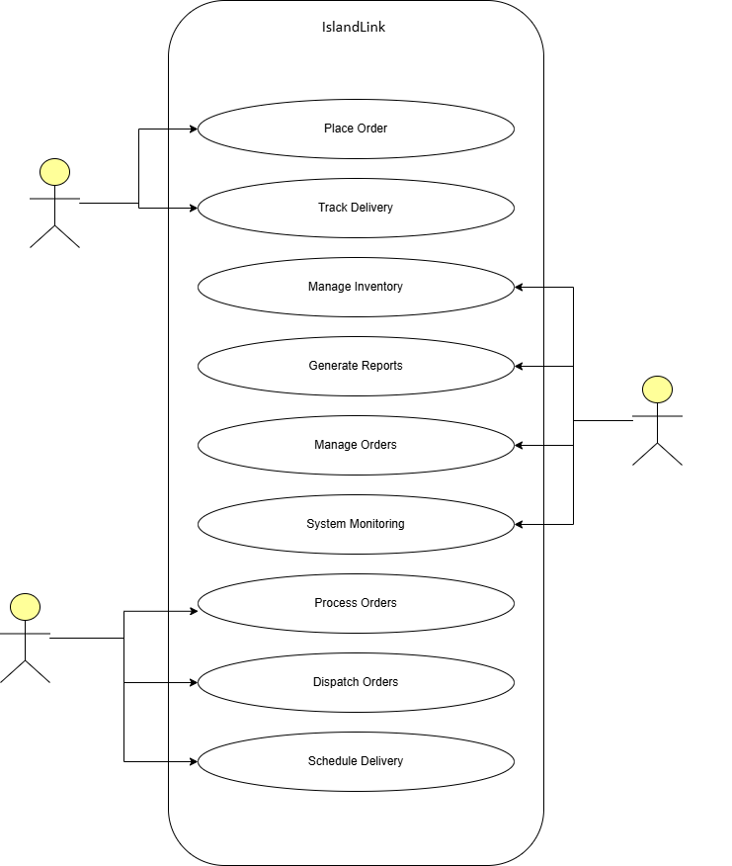
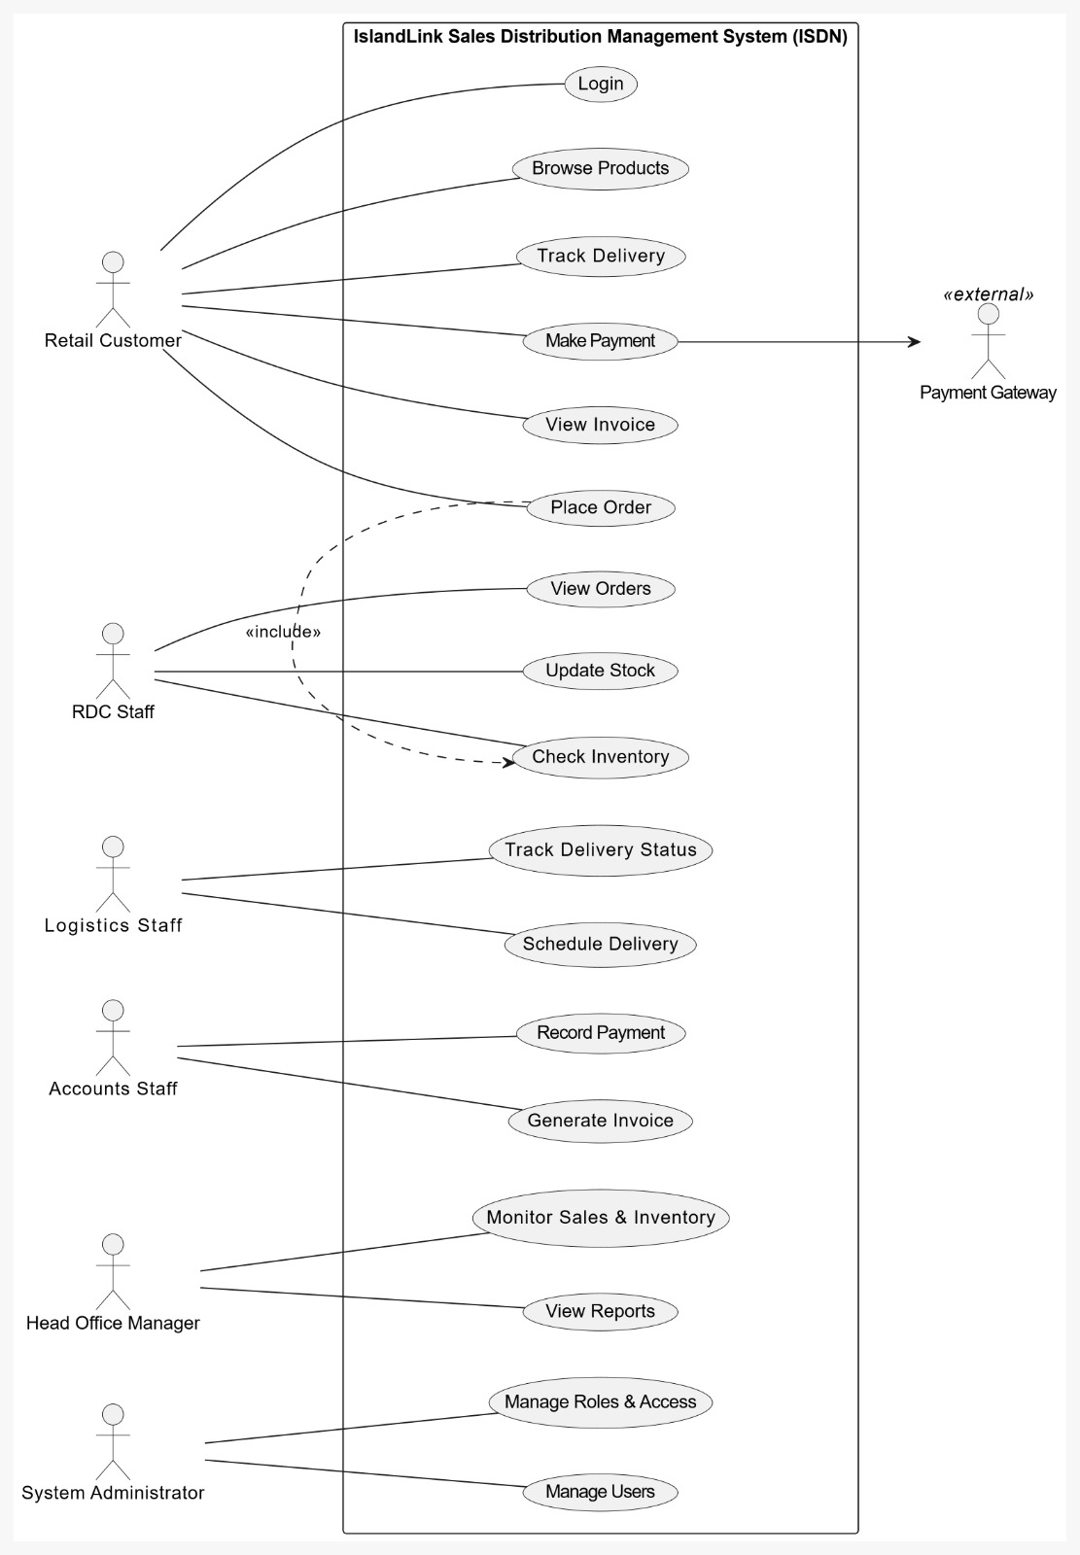

Class Diagram

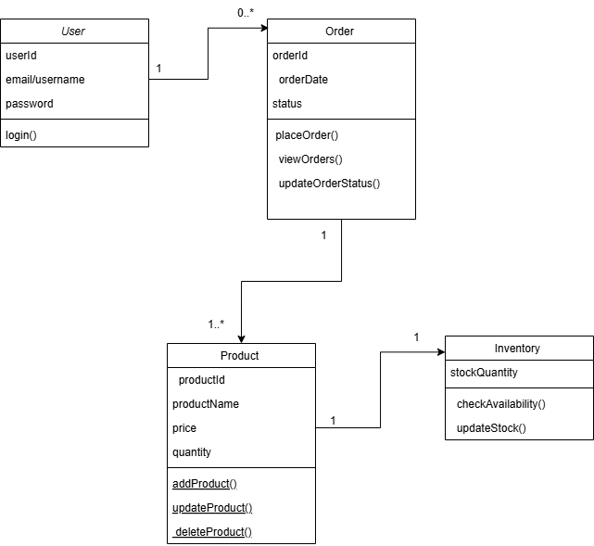

Three-Tier Architecture

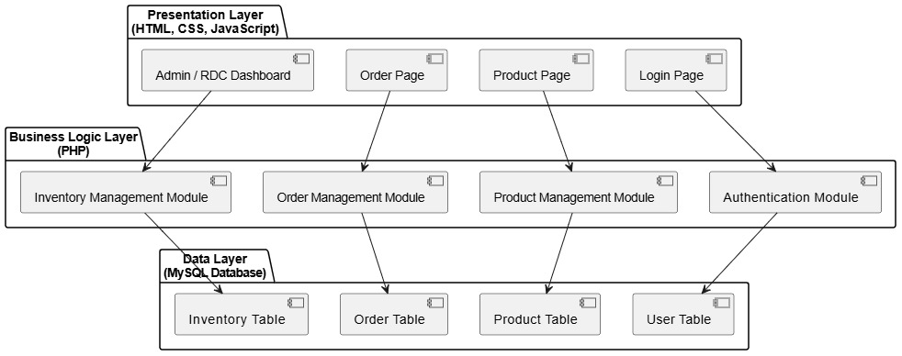

Software Architecture
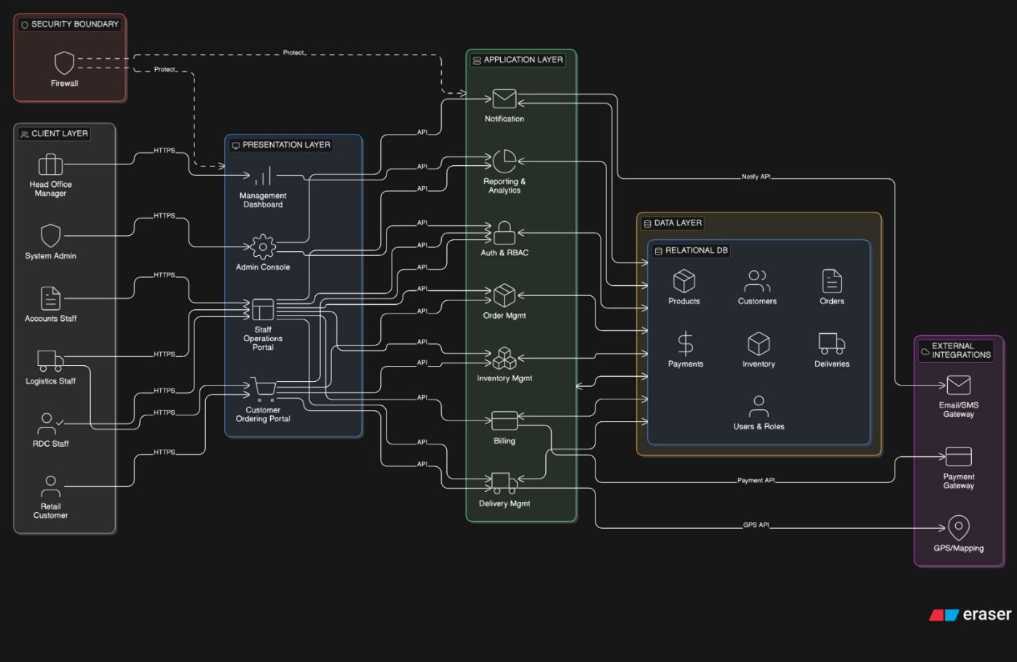

Develop User Interface

The design of the IslandLink SDMS (Sales Distribution Management System) User Interface (UI) has been created with an emphasis on ease-of-use, user-friendliness and a user-role based approach when creating and accessing the UI. The UI is web-based and built using HTML and CSS technology, therefore it works cross-platform on any browser which adheres to HTML/CSS standards.

Depending on the user role defined by the system user, a number of interfaces will be provided by the system. Customer interfaces will be designed for displaying product listings for ordering, while others for the RDC will be designed for product management (dispatch) and inventory management. Managers will be required to use interfaces designed for monitoring the system and user management. buttons, and user will be employed in the system to ensure that users perform operations in the system successfully and thus

There are several core functions of this system, which include login to the system, display of products, display of orders, modification of inventory, and notification alerts. The screenshots of these core pages are placed in the appendix of this user guide.

User manual

The login module allows registered users to securely access the system based on their role.

Steps

- first Open the system using a web browser.

- Enter a valid (role) email/username and password.

- Click the Login button.

- Upon successful authentication, the user is redirected to the appropriate dashboard (Admin, RDC Staff, or Customer).

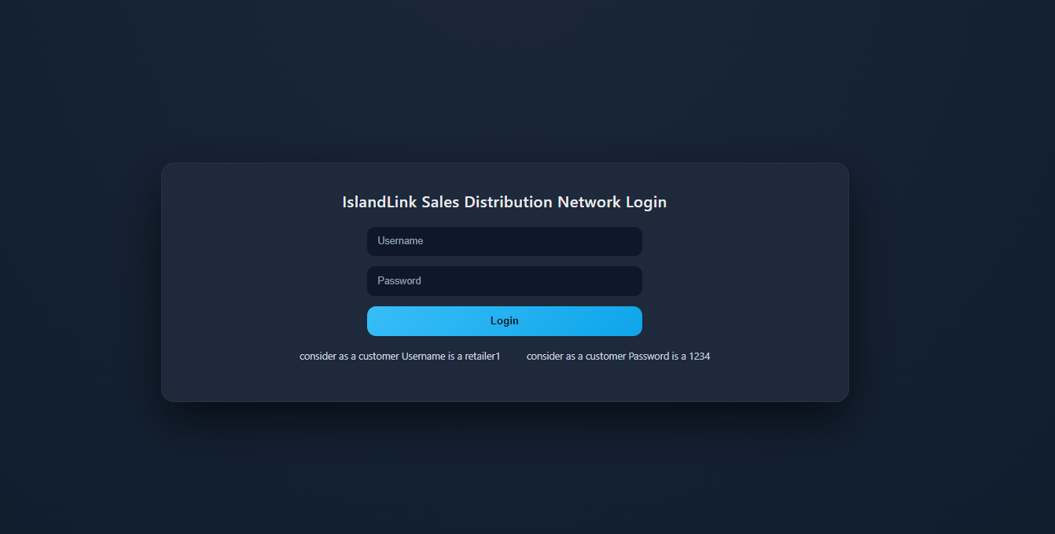

Customer dashboard

Customer successful log into the system after loaded customer dashboard
After customer can be a place an order

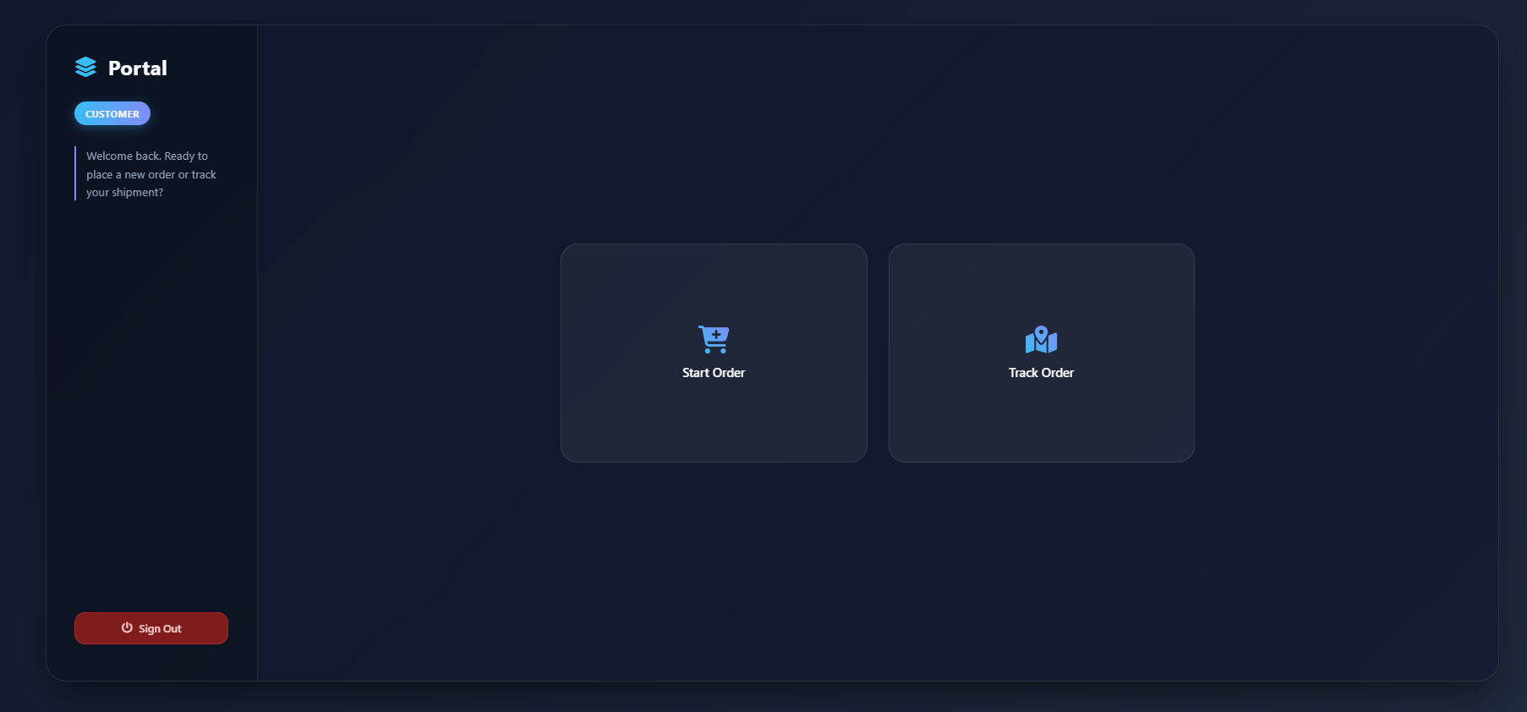

Customer placing orders.

Customers click a start order after customers can be a placing order

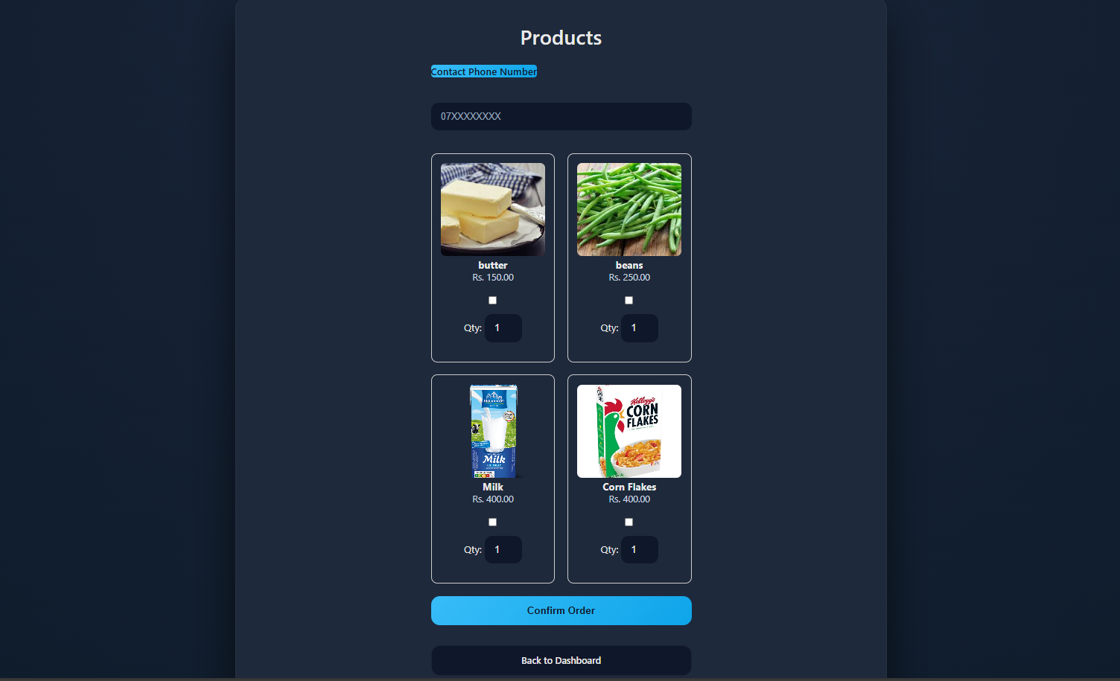

Manger’s dashboard
Manger’s successful log into the system after loaded Manger’s dashboard

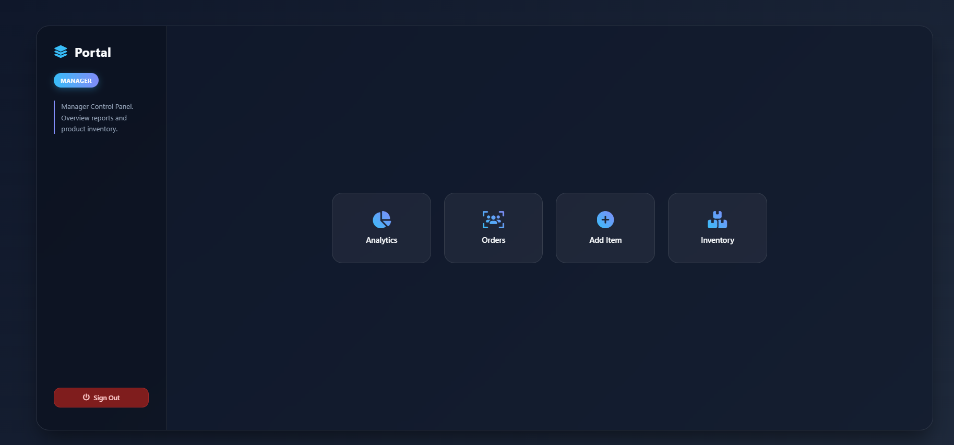
After login mangers can total of orders, order details, add a product and manage an inventory

After login mangers can click an analytics button manger can see a number of orders.
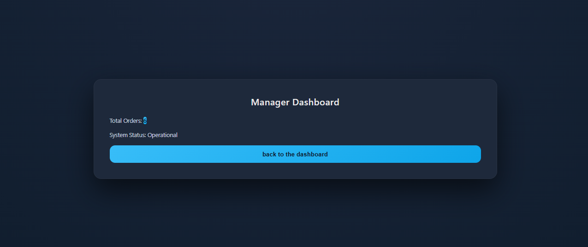
After login mangers can click a orders button mangers can see a customer’s order details.
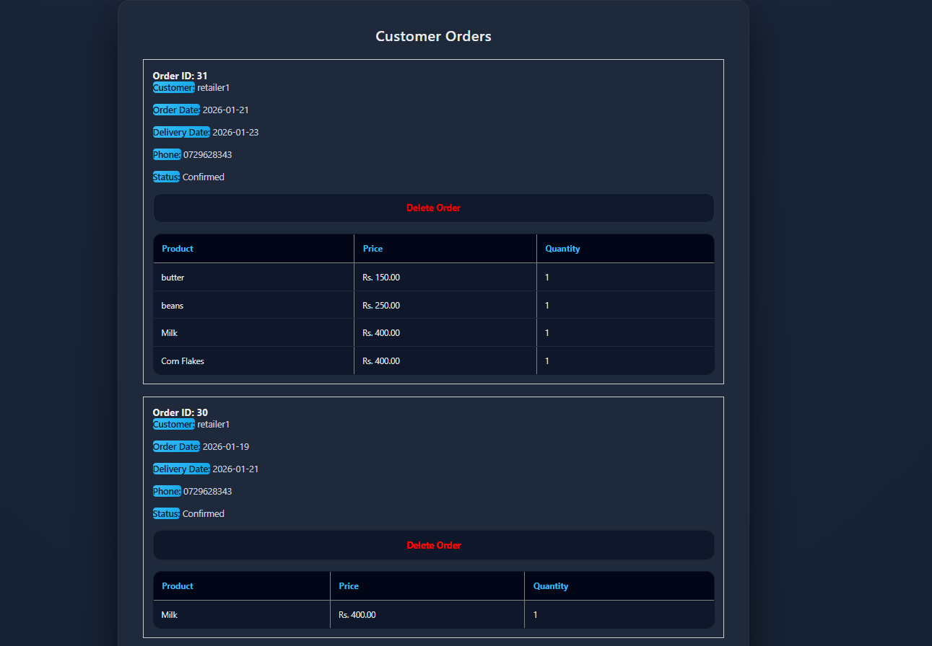

After login mangers can click an add item button mangers can add a products with including name price and product image.
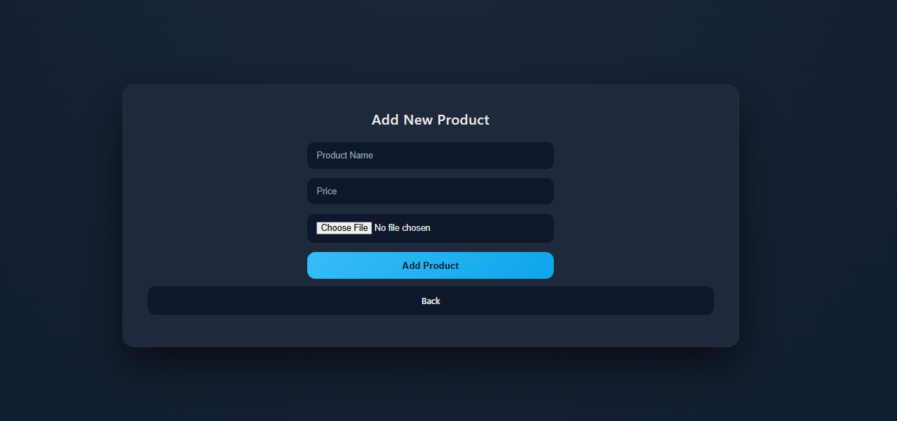
After login mangers can click an inventory button manger can see the product list and delete a unwanted products
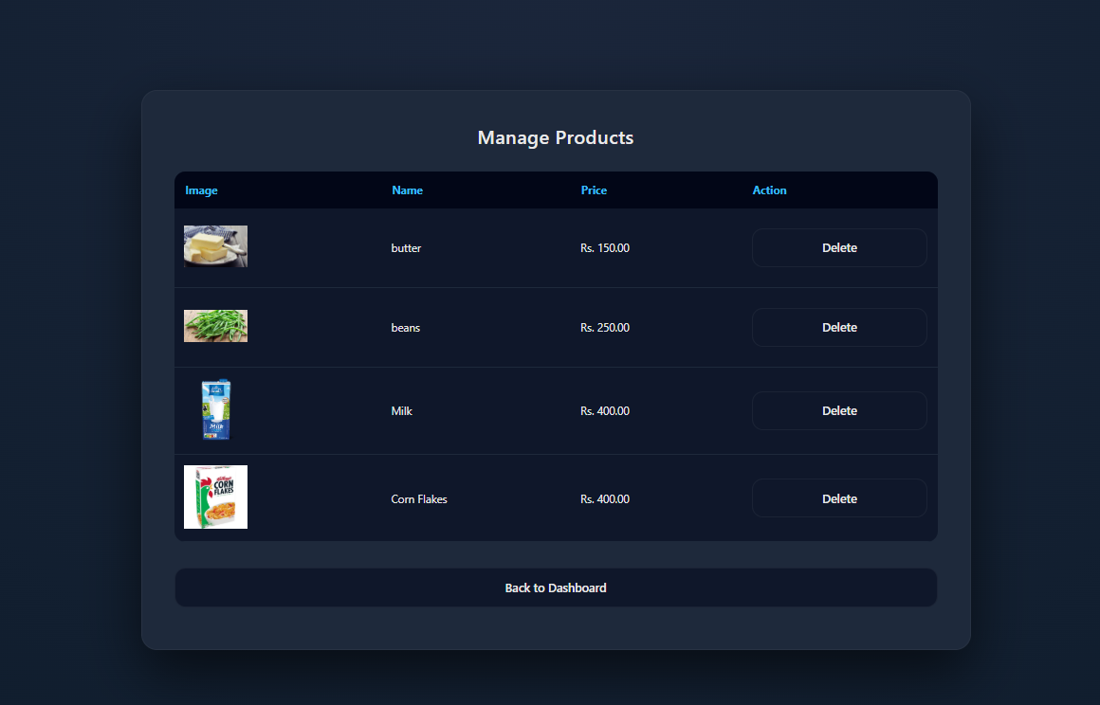

RDC dashboard
RDC successful log into the system after loaded RDC dashboard

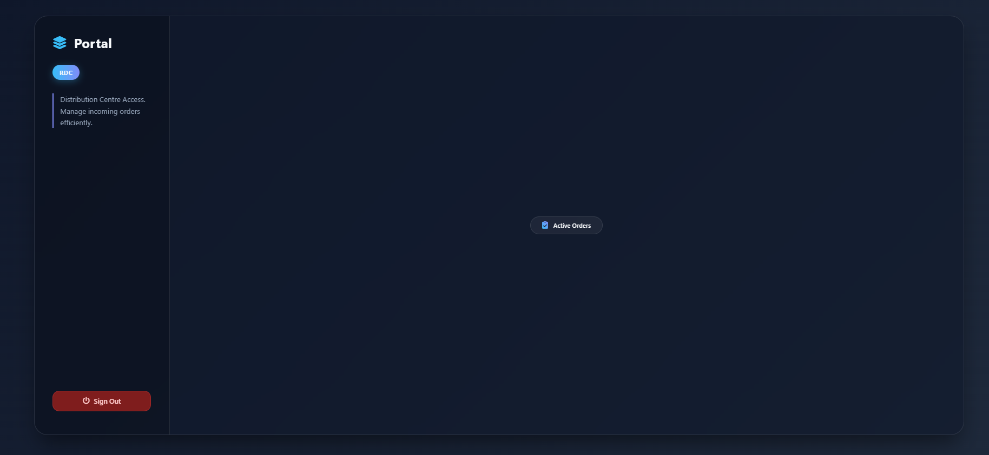

After login RDC can click an active order button RDC can be a dispatch or cancel the orders
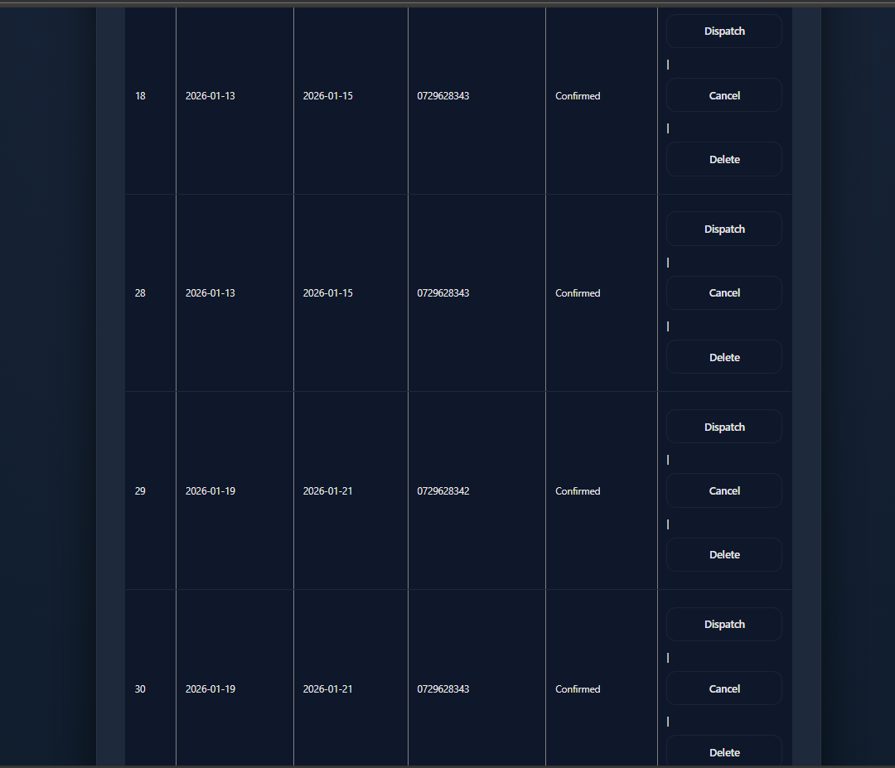

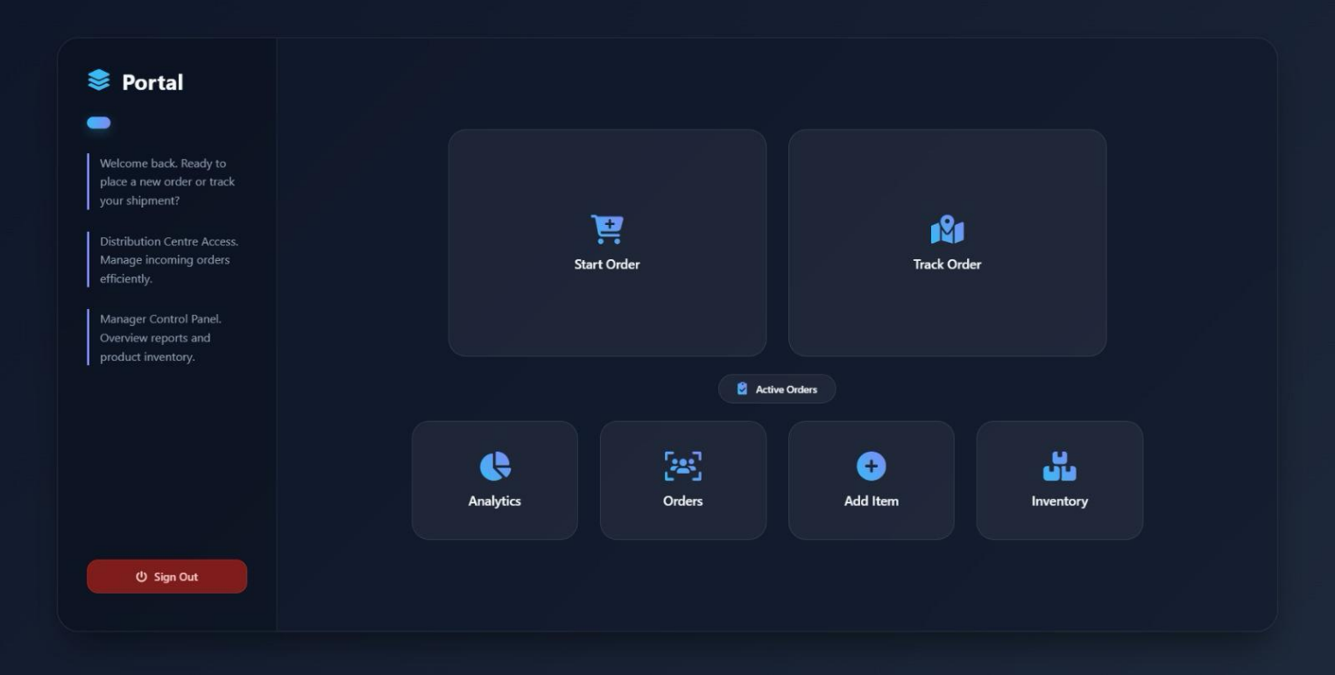
Portal Board

In here you can go to the tabs like, Start order, Analysis, Orders, Add item, Inventory.

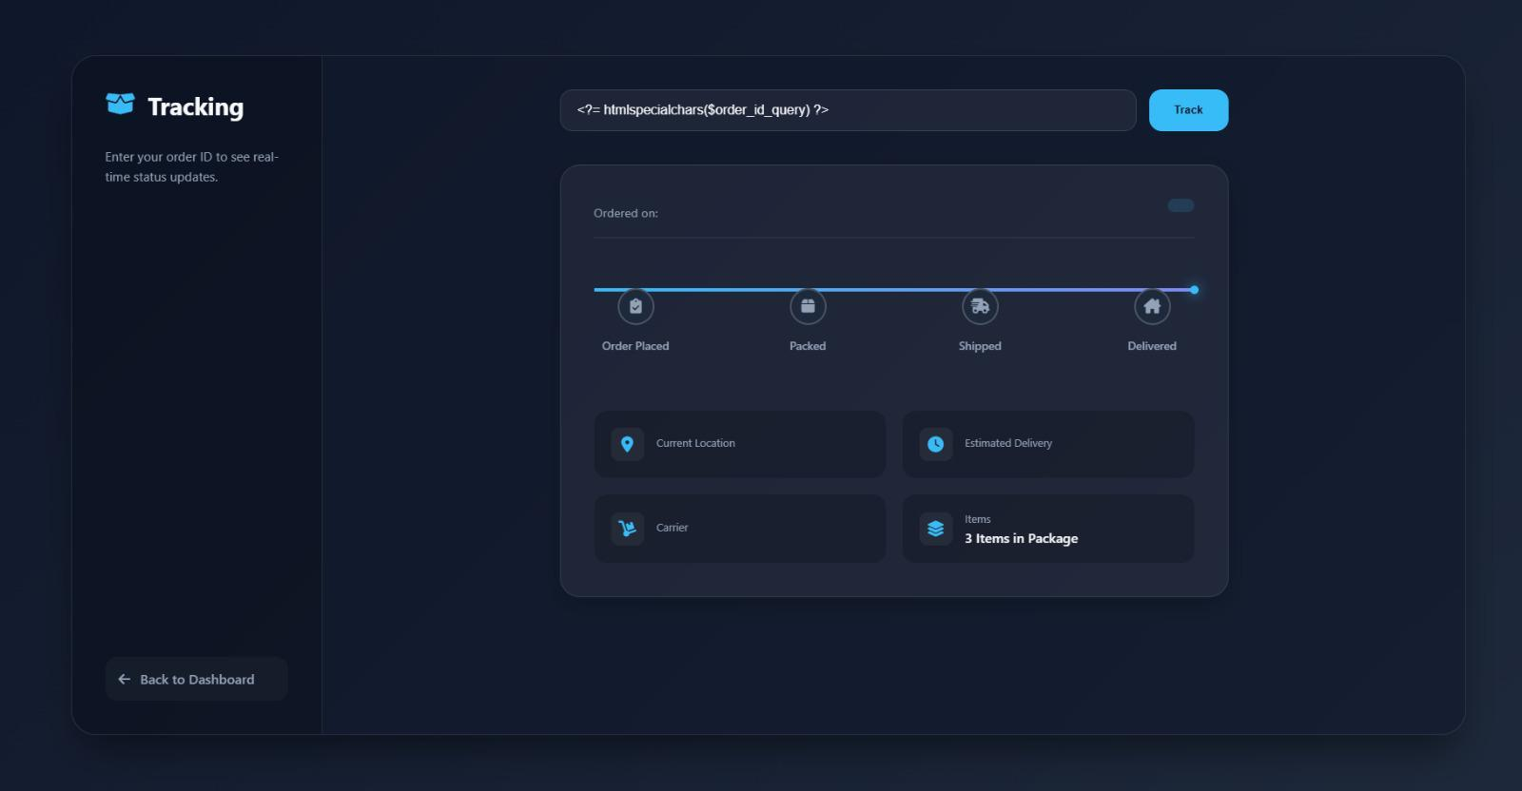
Tracking Page

You can see your orders and track your orders.

Individual tasks

Shevon Perera – Centralised Order Management Portal & Real-Time Inventory Synchronisation

The implemented components of the IslandLink Sales Distribution Management System as part of my individual contribution using HTML, CSS, PHP and MySQL. The main features developed included: Platform that can be used online and via mobile devices by customers to view products, place orders, order confirmations and estimated delivery dates. Different access levels for retail customers, RDC employees and Head office managers. Secure login with encryption of data for compliance with applicable laws.

Users IslandLink Sales Distribution Management System are authenticated through a login process based on their credentials using the role associated with them, e.g. Admin, RDC Staff, or Retail Customer.

Through the product of management module, users who have been given permission can manage product information including adding, updating, viewing, and deleting products. This allows to the user keeping accurate records of all product details, including: name, price, and available quantity. The order processing functionality enables customers to place orders by selecting products and quantities. while RDC staff can view and update order statuses. When the order placed.

Shenali Kurera - Real-Time Inventory Synchronisation & Delivery Scheduling & Tracking

Real-Time Inventory Synchronisation ensures that inventory levels across all Regional Distribution Centres (RDCs) and the Head Office are updated instantly whenever a stock movement occurs. This includes activities such as customer order processing, goods dispatch, returns, damaged items, and inter-branch stock transfers. The system automatically updates stock records in a centralised database, removing the need for manual updates and reducing human errors.
By maintaining a single, island-wide view of inventory, all RDCs and management staff can check accurate product availability in real time. Inter-branch stock transfer tracking allows managers to identify stock shortages or excess inventory at specific locations and redistribute stock accordingly. This improves inventory balance across the island, prevents order delays due to stock unavailability, and supports better planning and decision-making.

The Delivery Scheduling & Tracking feature automates the process of planning and managing deliveries from RDCs to retail customers. The system supports efficient delivery scheduling by organising orders based on delivery location, order priority, vehicle capacity, and required delivery timelines. This helps logistics teams plan daily delivery routes more effectively and reduce delays.
The system provides real-time delivery status updates such as “scheduled,” “dispatched,” “in transit,” and “delivered,” allowing both staff and customers to monitor order progress. Automated notifications keep customers informed about order confirmation and delivery status changes. This improves delivery visibility, enhances customer satisfaction, and allows RDC staff to quickly respond to delivery issues such as delays or rescheduling.

Individual Testing
(Shevon Perera)

All components created through the individual contribution underwent testing according to the Black Box Testing methodology, which validates the system's functionality by testing the system's external inputs and outputs while not considering how the internal code is structured.

That testing included a login of role based, adding products and deleting products, placing orders, and check inventory. these tests are involved using both valid and invalid input and that verify that the components of the system handled errors correctly and validated legitimate data appropriately. Each of the items in the test cases yielded the expected results, confirming that the component listed above perform as intended and meet the requirements of the system.

Real-Time Inventory Synchronisation & Delivery Scheduling & Tracking

The Real-Time Inventory Synchronisation component was tested using the Black Box Testing methodology. This approach focuses on validating system functionality by providing inputs and observing outputs without considering internal code structure. The goal was to ensure that inventory updates occur accurately and immediately after stock-related actions.
Testing scenarios included placing customer orders, dispatching items, performing stock transfers between RDCs, and handling insufficient stock situations. Both valid and invalid inputs were used to verify correct system behaviour and error handling.
The Delivery Scheduling & Tracking feature was tested using Black Box Testing to validate delivery status updates and scheduling functionality. The tests focused on ensuring that orders progress correctly through different delivery stages and that users receive accurate delivery information.
Various delivery scenarios were tested, including scheduling deliveries, updating delivery status, and handling delays or rescheduled deliveries. The system’s ability to display correct delivery status information to both staff and customers was verified.

Test cases
(Shevon Perera)

Test Case | Feature | Input | Expected Result | Actual Result | Status
01 | User Login | Input Valid username and password | User logged in successfully | 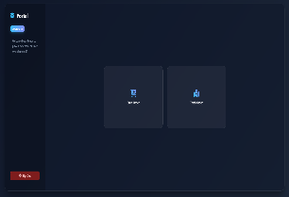  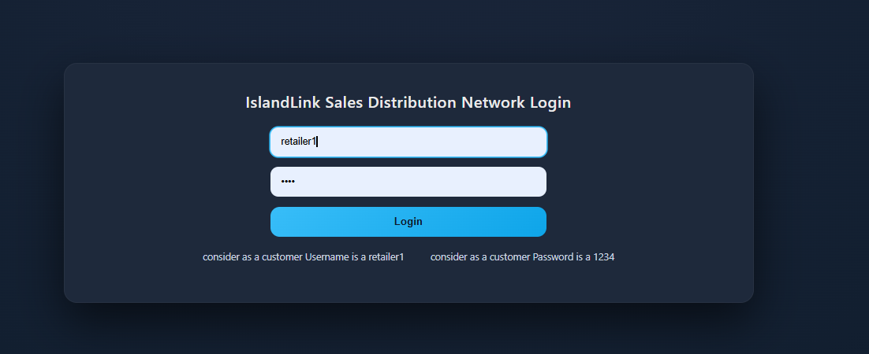 | Pass
02 | User Login | Invalid credentials | Error message displayed | 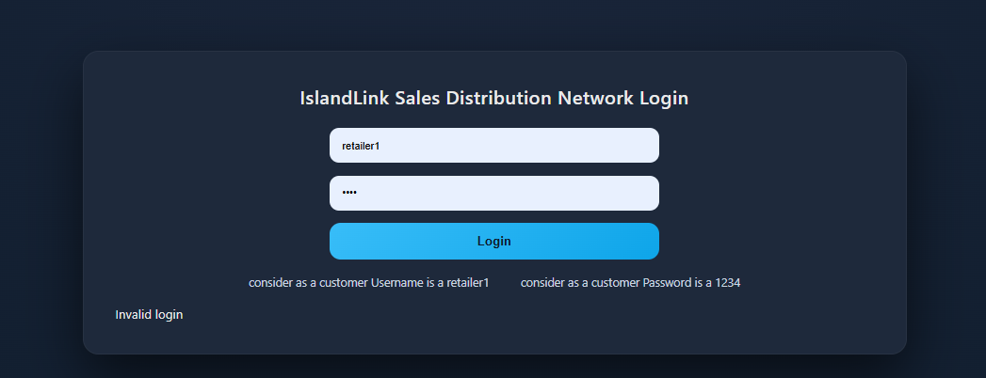 | Pass
03 | Add Product | Input product details | Display Product added successfully massage | 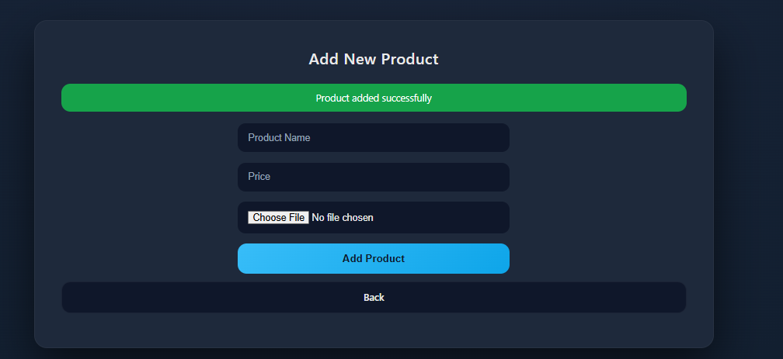 | Pass
04 | Delete Product | Delete product selected | Product removed successfully | 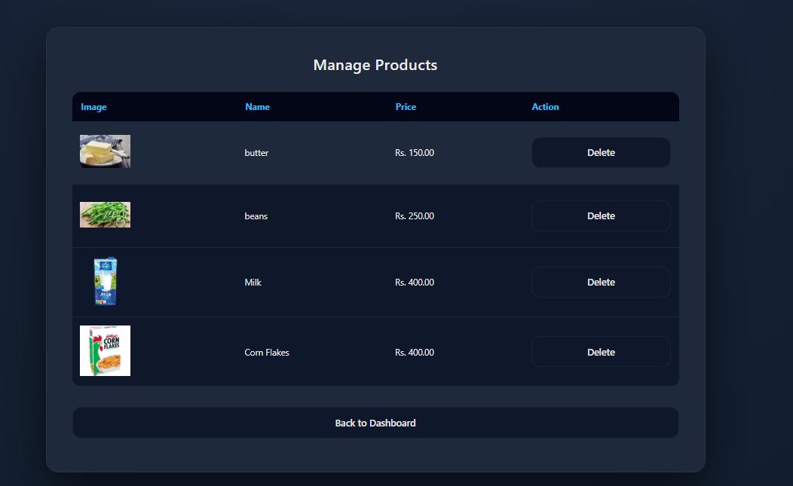 | Pass
05 | Place Order | Valid product and quantity | Order placed successfully | 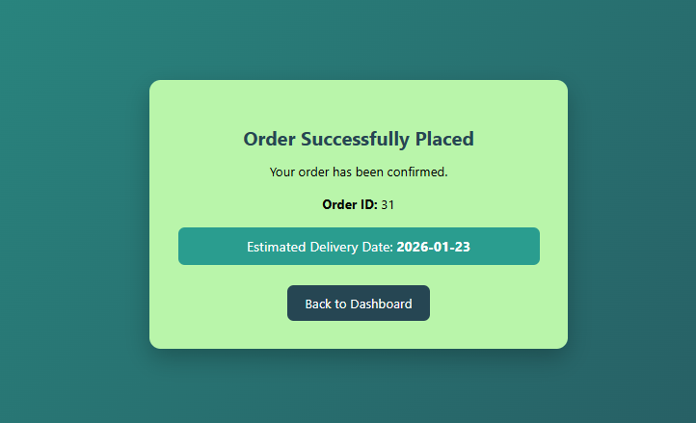 | Pass

Individual Reflection

(Shevon perera)

The Agile methodology used for the project was very effective for managing the development of the IslandLink Sales Distribution Management System. The approach of working in a cycle helped the team deliver the functional pieces of the system incrementally, simultaneously improving the system features. The approach helped in overcoming the challenges faced in large-scale software development.

Collaboration among the team or individual members was another strong point in this project. The work was well divided among the team members, allowing each member to work on selected parts of the system. This helped in the overall implementation of the system. The progress among the team members helped in the identification problems at an early stage.

In the individual perspective, implementing of the authentication, management of product, and order processing features improved my understanding of web development. I capture practical experience of handling user roles, database interactions, and form using PHP and MySQL. however, integrating inventory updates with order processing helped to the understand of importance in data consistency in distributed systems.

They own components highlight the importance behind having a proper Quality Assurance system in place to provide confidence in Software Engineering. these use of Black Box Testing, I was able to confirm the system behaved appropriately for various types of input provided. This process reinforced the message that Testing should also include not only successful Testing outcomes, but also, Invalid Input Testing and edge-case Testing.

Overall, Despite the fact that part of the project was successful but there are areas that need and can be a identify to be improvement. The management of time is most important. The management of time is could be helps to improve by adding more buffer time in the event of unexpected problems. the Integration testing among the members of the group would also be beneficial in overcoming minor compatibility problems.

This project proved to be a very good beneficial learning experience for me in improving all of my technical skills, individual experience and the team work skills. The fact that this project involved a similar real-world inspired system has added to my knowledge of how concepts such as requirement analysis, system design, and testing in software engineering are applied in real-world systems. This project has again reinforced for me the need for formal system design using UML modelling to ensure alignment of system specifications with their implementation. another thing is, this team development activity has helped to improve my communication skills and reinforced for me the need for coordination and shared responsibility in a team environment. This has further boosted my confidence in designing web-based systems.

Implemented code (Shevon Perera
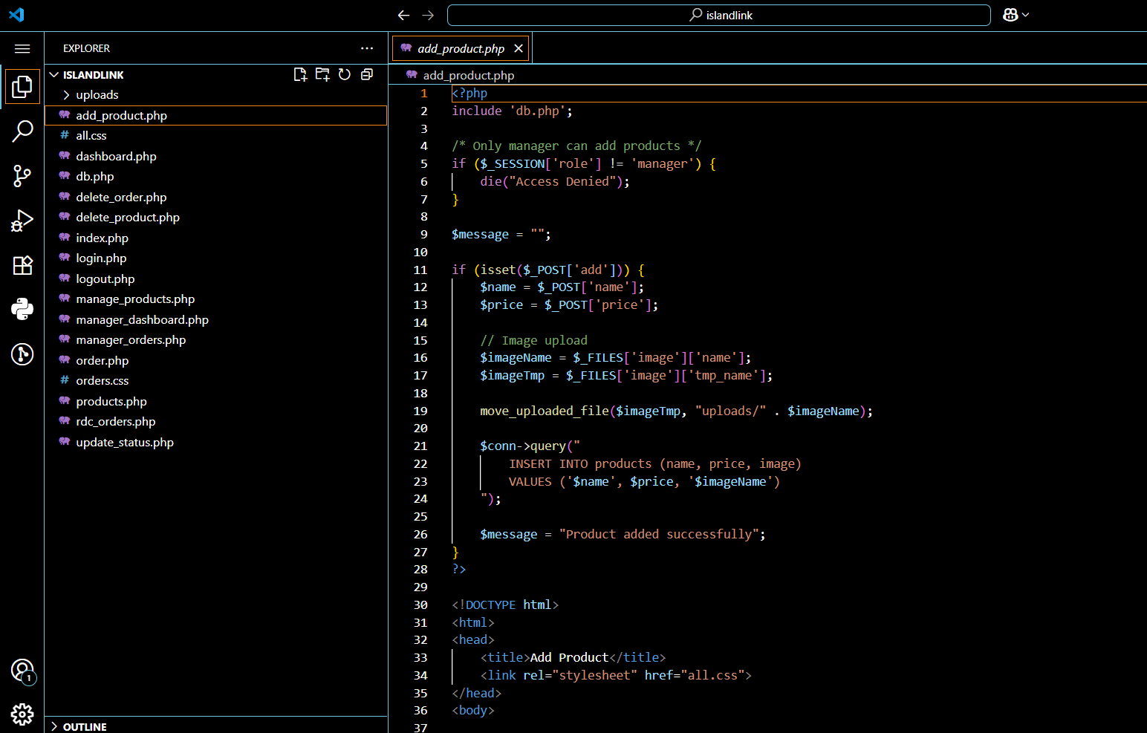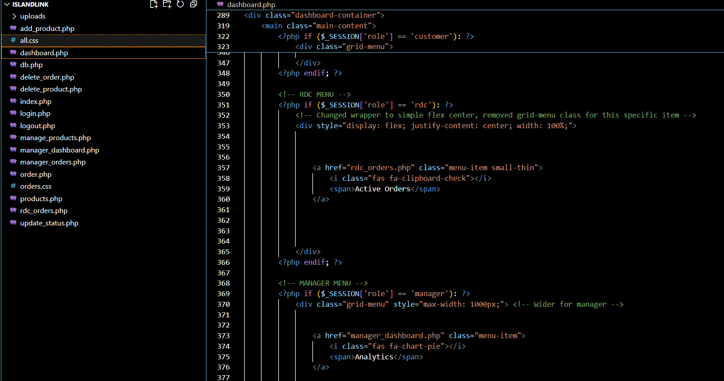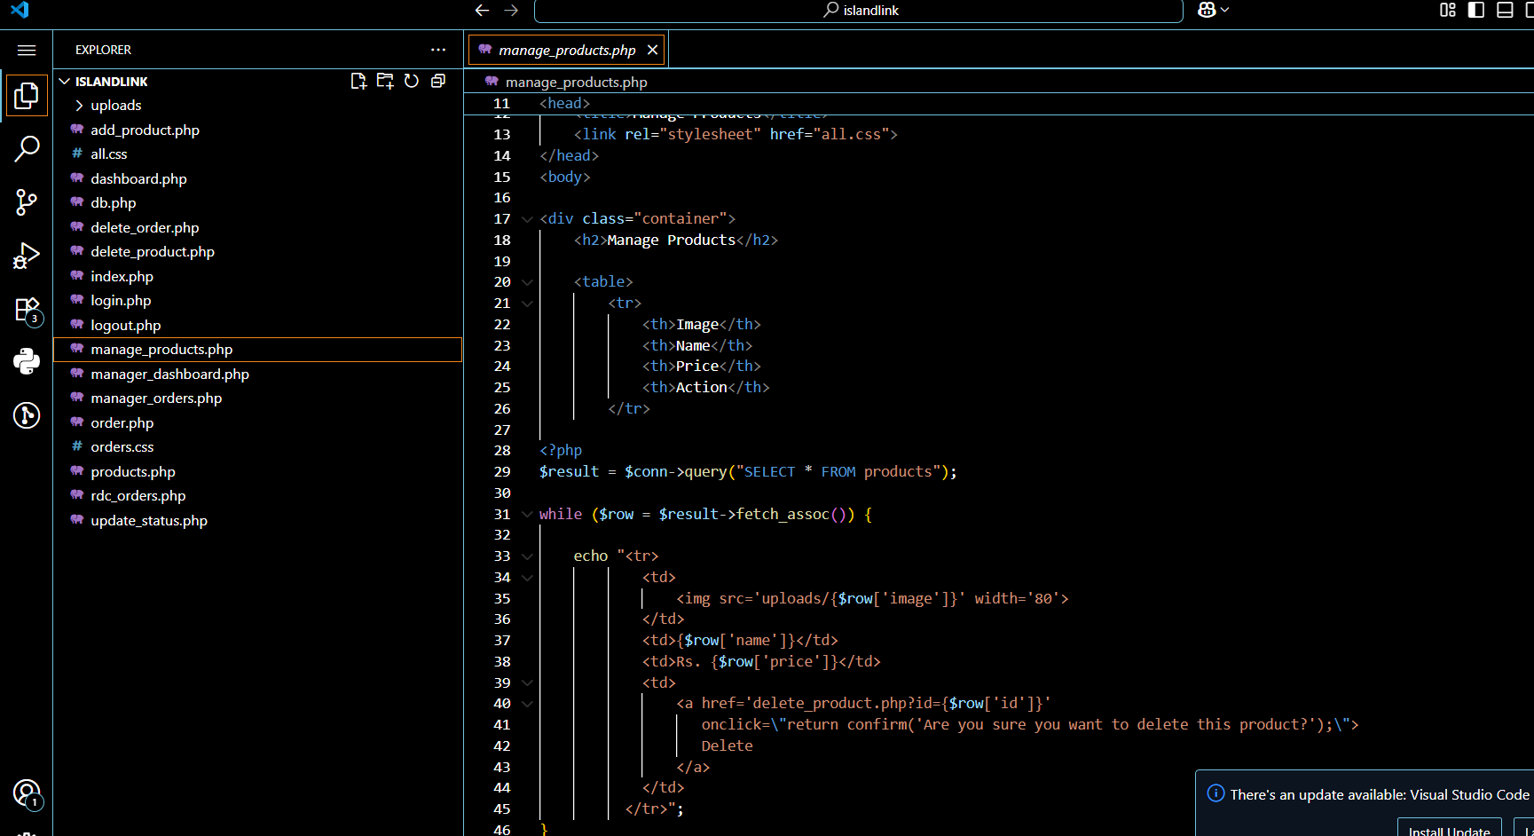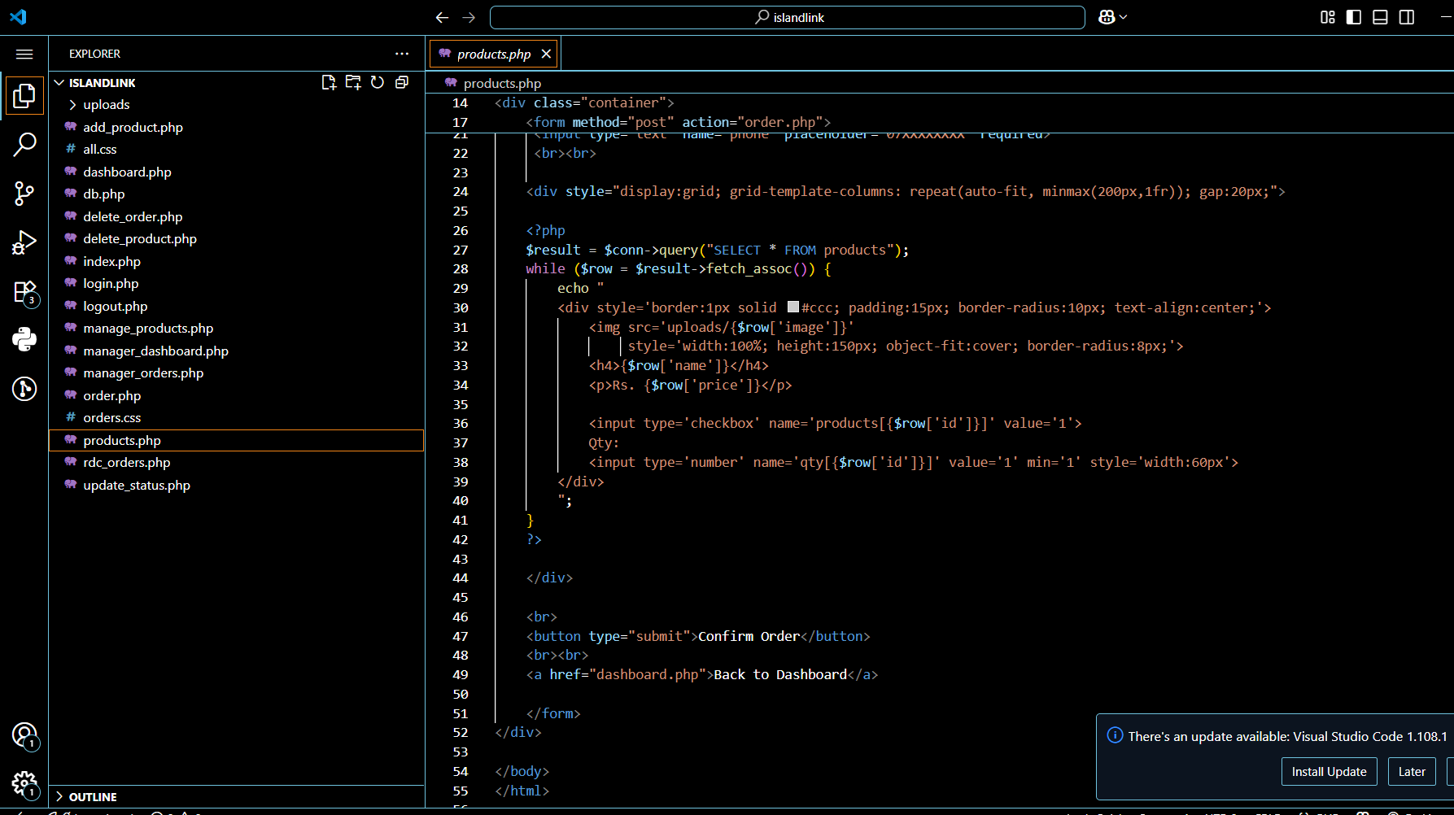

Real-Time Inventory Synchronisation & Delivery Scheduling & Tracking

